# FLEXBOX FROGGY

**Lvl1**



**Lvl2**



**Lvl3**



**Lvl4**



**Lvl5**



**Lvl6**



**Lvl7**



**Lvl8**



**Lvl9**



**Lvl10**



**Lvl11**



**Lvl12**



**Lvl13**



**Lvl14**



**Lvl15**



**Lvl16**



**Lvl17**



**Lvl18**



**Lvl19**



**Lvl20**



**Lvl21**



**Lvl22**



**Lvl23**

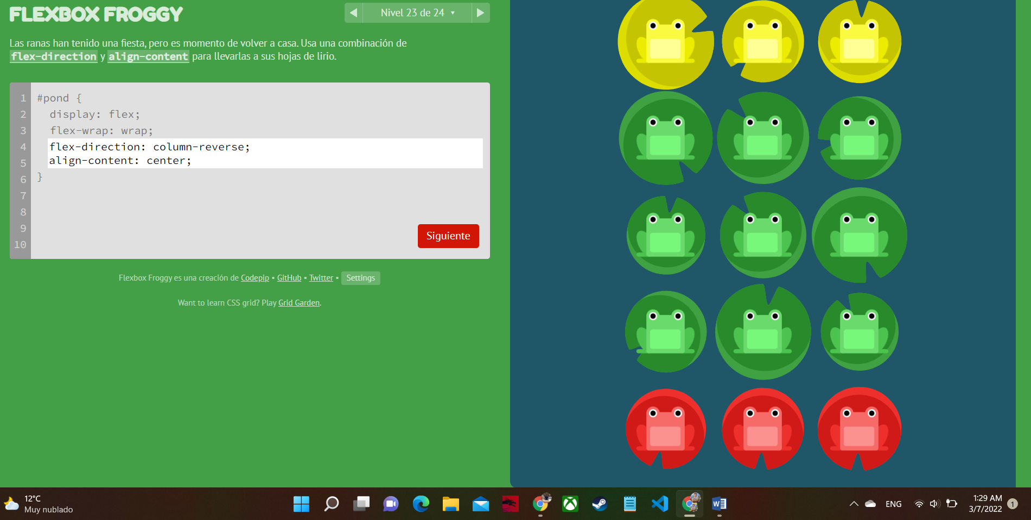

**Lvl24**



**Done.**

**CV SAXTON HALE**

**HTML:**

<!DOCTYPE html>

<html lang="en">

<head>

    <meta charset="UTF-8">

    <title>curriculum vitae</title>

    <link rel="stylesheet" type="text/css" href="style.css">

</head>

<body>

        <header>

            <h1><center>SAXTON HALE</center></h1>

        </header>

        <main>

            <section>

                <article>

                    <p><center>

                        "The name's Saxton Hale. Australian. C.E.O. at Mann Co.

                        And the man who's gonna burn this place to the ground..!"

                    </center></p>

                    <div id="main">

                        <div id="image">

                        <figure>

                            <img src="Yourpropertyjustgotdamagedbysaxtonhale.png" alt="Saxton Hale">

                            <figcaption><p>Saxton Hale</p></figcaption>

                        </figure></div>

                        <div id="Characteristics">

                            <ol><h2>Features, Qualities and Defec... Virtues</h2>

                                <li><p>Daring Australian.</p></li>

                                <li><p>Considered Fourth richest man in America.

                                    He was the sixth richest man in America, but surpassed the fifth by wealth and the fourth by killing him in a harpoon duel.</p></li>

                                <li><p>His birthday is unkown.</p></li>

                                <li><p>His favorite pastimes include fighting, drinking, and battling with ferocious animals.

                                    In fact, most kids sleep with a teddy bear at night, but Saxton Hale sleeps with an actual bear that he tamed while in the Brazilian Jungles.</p></li>

                                <li><p>His identifying features include a mustache, rippling muscles, a crocodile-tooth lined hat, and a patch of rotating chest hair shaped like Australia.</p></li>

                                <li><p>He also refuses to wear clothes on his upper body "for obvious reasons".</p></li></ol>

                        </div>

                        <div id="image">

                        <figure>

                            <img src="Saxtonisgoddamnedmanly.png" alt="Saxton Hale in combat with sharks.">

                            <figcaption><p>Saxton Hale in combat with sharks.</p></figcaption>

                        </figure></div>

                        <div id="Achievements">

                            <ol><h2>Notable Achievements</h2>

                            <li><p>Cutting his way out of "primate hell".</p></li>

                            <li><p>Teaching his Girl Scout troop, the "Saxtonettes", fire safety tips such as "Grizzly bears burn".</p></li>

                            <li><p>Fighting off a lion while simultaneously having a haircut.</p></li>

                            <li><p>Single-handedly wiping out the Indonesian Berserker Shark (and making them cry).</p></li>

                            <li><p>Retrieving a stolen puck from a thieving tortoise despite its thirty minute head start.</p></li>

                            <li><p>Inventing Jarate, the JAR-Based karate.</p></li>

                            <li><p>Becoming the wealthiest man in the Western Hemisphere.</p></li>

                            <li><p>Becoming the fourth richest man in America.</p></li>

                            <li><p>Firebombing Woodstock from a helicopter.</p></li>

                            <li><p>Being in no way involved with the explosive death of the American monkeynaut Poopy Joe, nor being anywhere near the launch site at the time.</p></li>

                            <li><p>Publishing a special issued magazine (at a price of 20 cents per issue, even though it was demanded to be free) to answer questions made by his fans about, among other things, playing Team Fortress 2 on a Mac.</p></li>

                            <li><p>Discovering the existence of the Internet and starting the Mann Co. Store.</p></li>

                            <li><p>Purchasing England.</p></li>

                            <li><p>Fixing reading.</p></li>

                            <li><p>Having a website made up entirely of absolutely true Saxton Hale facts.</p></li>

                            <li><p>Killing the perverts at AnagramYourName.com.</p></li>

                            <li><p>Hosting the First Annual Saxxy Awards.</p></li>

                            <li><p>Inventing the "high-five".</p></li>

                            <li><p>Eating a whole ostrich.</p></li>

                            <li><p>'Manslaughtering' 1593 physicians.</p></li>

                            <li><p>Defeating Dr. McNinja in a popularity contest.</p></li>

                            <li><p>Slamming the last living Yeti with a Scout.</p></li>

                            <li><p>Jumping off a thrown Scout to punch that Yeti into a mess of blood and gibs.</p></li></ol>

                        </div>

                        <div id="image">

                        <figure>

                            <img src="1200px-AFateWorseThanChess7.jpg" alt="Saxton Hale">

                            <figcaption><p>Saxton Hale Fixing reading</p></figcaption>

                        </figure></div>

                        <div id="BCN">

                            <h2>Contact Information</h2>

                                <p>email: saxtonhale@manncostore.com</p>

                                <p>Best contact number: +1 310 698 9608</p>

                                <p>Dirección de residencia: Avenida Alaska Calle Piloto - La Cueva.</p>

                        </div>

                        <div id="image">

                        <figure>

                            <img src="Mann_Co._Logo.png" alt="Descripcion">

                        </figure></div>

                    </div>

                </article>

            </section>

        </main>

</body>

</html>

**CSS**

*{

    margin: 0;

    padding: 0;

}

body{

    background: ghostwhite;

    font: 0.8em/1.2 Verdana;

}

#main{

    width: 1125px;

    margin: 2% auto;

}

#Characteristics{

    line-height: 17.8px;

    width: 562.5px;

    margin: 2% auto;

    background: rgb(156, 148, 148);

    float: left;

    text-align: initial;

}

#Achievements{

    line-height: 50px;

    width: 562.5px;

    margin: 2% auto;

    background: rgb(104, 98, 99);

    float: left;

    text-align: initial;

}

#BCN{

    line-height: 20px;

    margin: 2% auto;

    background: rgb(195, 135, 222);

    text-align: left;

}

#image{

    line-height: 20px;

    margin: 2% auto;

    image-resolution: inherit;

}

**PAGE**

